RECORD MANAGEMENT SYSTEM PROJECT

– GROUP A

DESIGN, IMPLEMENTATION AND EVALUATION OF A PYTHON-BASED RECORD MANAGEMENT SYSTEM FOR A SPECIALIST TRAVEL AGENT

By
Software Developers:
Student | Master of Science
Eboserieme Anetor | DATA_SCIENCES_AND_AI
Mohamed Ahmed Deria | CYBER_SECURITY
Brentin Govender | DATA_SCIENCES_AND_AI
Amber Mary-Anne Harris | CYBER_SECURITY
Abdel Fattah Hasan | DATA_SCIENCES_AND_AI

Submitted to

The University of Liverpool

CSCK541 Software Development in Practice
January 2026 B

Word Count: 942

23/03/2026

RECORD MANAGEMENT SYSTEM PROJECT

– GROUP A

DESIGN, IMPLEMENTATION AND EVALUATION OF A PYTHON-BASED RECORD MANAGEMENT SYSTEM FOR A SPECIALIST TRAVEL AGENT

Submitted to

The University of Liverpool

Word Count: 942

23/03/2026

TABLE OF CONTENTS

Page

LIST OF TABLES 2

LIST OF FIGURES 3
- Introduction 4
- Methodology and System Architecture 5
- Implementation 6
- Testing and Evaluation 8
- Conclusions and Recommendations 9

REFERENCES 10

APPENDICES 11

LIST OF TABLES

Page
Table 1 – Record Definition 6
Table 2 – Tests Coverage and Results Summary 8
Table 3 – Repository Component and Purpose 11

LIST OF FIGURES

Page

Figure 1. Layered Architecture of the RMS 5
Figure 2. Final GUI of Simply A Tourism 7
Figure 3. Test Output Evidence 8
Figure 4. Repository Structure in the GitHub 12

Introduction

This report documents the software development of a Record Management System (RMS) written in Python for a travel agency, Simply A Tourism. The requirement for the system was a Graphical User Interface (GUI) for the addition, deletion, modification, searching and display of client, airline and flight information. The data had to be held in memory in the form of a list of dictionaries and then written to a file on a PC. A layered approach was implemented into the system as it is generally considered good practice for large and complex applications, also enables easy maintenance and testing (Sommerville, 2016; Martin, 2008).

Methodology and System Architecture

The RMS application was divided into main five levels with namely GUI, CRUD, validation and storage with additional permanent storage (Figure 1). The GUI is built by using Tkinter forms to get the input from users and pass the input to the corresponding record handlers. The CRUD modules include functions for creating, searching, editing and deleting records in the application data, as well as some helper functions to avoid code duplication. The validation layer is to check the input data before it is written to the storage layer. The storage layer is used to load and save all records to the shared in-memory record store when the application is started and closed. The application structure implemented here will also benefit the maintainability and fault isolation of the application (Sommerville, 2016). Figure 1 also shows the control flow in the application structure.
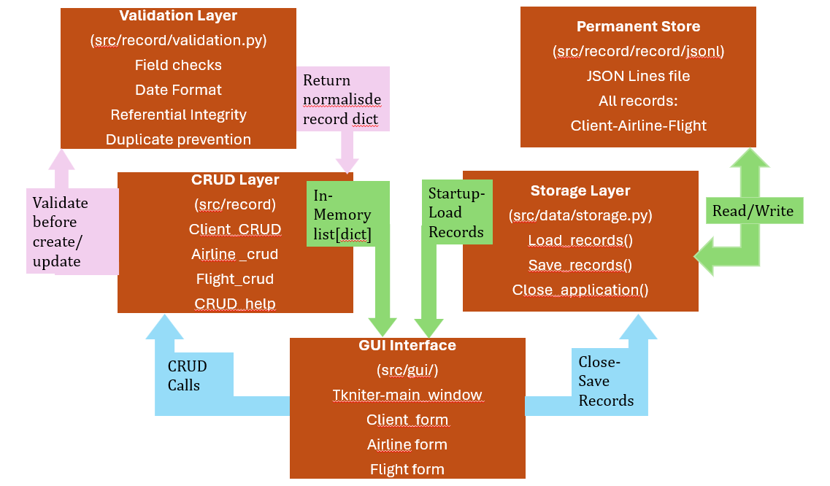
Figure 1. Layered Architecture of the RMS

Implementation
GitHub’s repository was created, and tasks were distributed among the developers (Appendices A to C).
Three required record types (Client and Airline information and flights) have all been placed in a shared in-memory list of dictionaries (Table 1). The Client and Airline records are simply identified by integer IDs. No separate ID for a single flight, but identified each flight using a composite key consisting of Client_ID, Airline_ID, Date, Start City and End City keys. Though, a single flight ID would still be preferable once the system is upgraded.
Table 1 – Record Definition
Entity | Required Fields | Data Types
Client | ID, Type, Name, Address Lines 1–3, City, State, Zip Code, Country, Phone Number | Integer ID;  strings otherwise
Airline | ID, Type, Company Name | Integer ID;  strings otherwise
Flight | Client_ID, Airline_ID, Date, Start City, End City | Integer foreign keys; date/time and strings

The GUI supports all common operations of database applications like adding, searching, editing and deleting records using dynamic forms and depending on the type of record and the operation to be performed. Following the principles of minimalism and consistency (Krug, 2013; Morville and Rosenfeld, 2006), the application keeps non-essential information away from the user’s focus. The required fields of the application are dates in the right format, and the flight/client/airline references correct, and that there are no duplicated flights in order to protect the underlying format of the flexible database. The application structure implemented here also follows UX principles, which suggest that the user interface should be as simple, consistent and intuitive as possible (Hartson and Pyla, 2019, pp. 3–25, 359–383; Krug, 2013). The final graphical user interface (GUI) of the RMS of Simply A Tourism is shown in figure 2. Guidelines of W3C (2024) for accessibility were employed to ensure that RMS is perceivable, operable, understandable and robust (W3C, 2024).
For persistence, JSON Lines courtesy of the jsonlines package were used. JSON serialization selected here since the Python dictionary structure in the data model aligned with JSON objects (Python Software Foundation, 2026a). The storage layer handles missing, empty and malformed files, which should make it suitable for a desktop application.
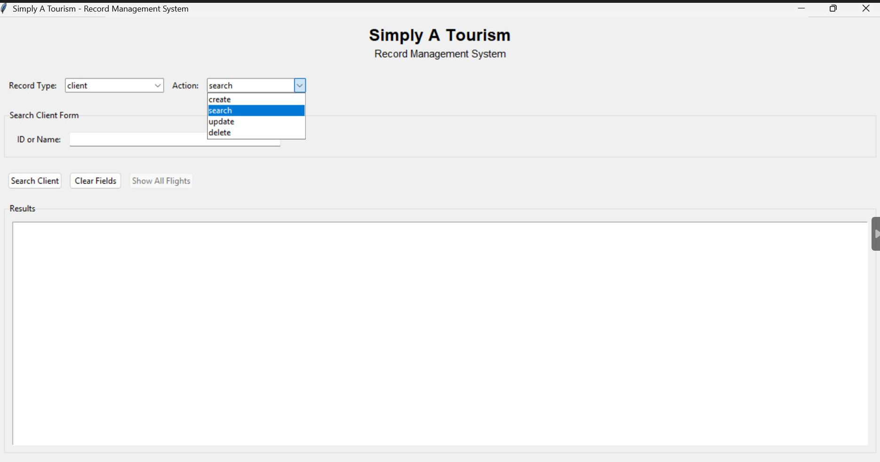
Figure 2. Final GUI of Simply A Tourism

Testing and Evaluation
Testing was done using the Python’s unittest framework. This allowed an automatic running of tests, also enabled the use of fixtures and test suites (Python Software Foundation, 2026b). There were tests for the common CRUD helpers, client, airline and flight functions, as well as the validation rules. There were also tests for the data storage and full end-to-end integration tests, covering the load, modify, save, and restart (Table 2; Figure 3). In total, 79 tests passed successfully after checking a whole range of common cases, edge cases, and spread them out over invalid dates, duplicate flights, missing records searches and session persistence.
Table 2 – Tests Coverage and Results Summary
Test Module | Component | Test Cases | Results
Item | Item | Item | Item
test_crud_helpers.py | Shared CRUD algorithms | 16 | Passed
test_client_crud.py | Client record operations | 11 | Passed
test_airline_crud.py | Airline record operations | 11 | Passed
test_flight_crud.py | Flight record operations | 22 | Passed
test_validation.py | Integrity and format rules | 9 | Passed
test_storage.py | File I/O and fault tolerance | 8 | Passed
test_integration.py | Application lifecycle | 2 | Passed
Total | 79 |  | All tests passed

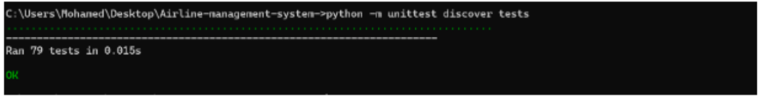
Figure 3. Test Output Evidence

Conclusions and Recommendations

The modular design of the RMS supported the coding validation and testing with maintainability, and high testability (Martin, 2008; Sommerville, 2016). The validation layer is crucial to ensure that the structure and referential integrity of the data is upheld, regardless of storage mechanism or presentation, and is vital in order to take full advantage of the use of a common list-of-dictionaries (or similar) data structure abstraction. JSONL persistence was also suitable due to its readability and sufficiency for single users.
The RMS can be improved by introducing a dedicated flight ID. File storage can also be designed for concurrent access. The GUI is adequate, but can be improved in terms of hierarchy, help on fields, feedback of status and accessibility.

REFERENCES
GitHub Docs (n.d.) About Git. Available at: https://docs.github.com/en/get-started/using-git/about-git (Accessed: 21 March 2026).
Hartson, R. and Pyla, P.S. (2019) The UX Book: Agile UX Design for a Quality User Experience. 2nd edn. Cambridge, MA: Morgan Kaufmann.
Krug, S. (2013) Don’t Make Me Think, Revisited: A Common Sense Approach to Web Usability. 3rd edn. Berkeley, CA: New Riders.
Martin, R.C. (2008) Clean Code: A Handbook of Agile Software Craftsmanship. Upper Saddle River, NJ: Prentice Hall.
Morville, P. and Rosenfeld, L. (2006) Information Architecture for the World Wide Web: Designing Large-Scale Web Sites. 3rd edn. Sebastopol, CA: O’Reilly Media.
OWASP (2025) OWASP Top 10:2025. Available at: https://owasp.org/Top10/2025/ (Accessed: 21 March 2026).
PyInstaller (n.d.) Guidelines for Commits — PyInstaller 6.19.0 documentation. Available at: https://pyinstaller.org/en/stable/development/commit-messages.html (Accessed: 21 March 2026).
Python Software Foundation (n.d.a) json — JSON encoder and decoder. Available at: https://docs.python.org/3/library/json.html (Accessed: 21 March 2026).
Python Software Foundation (n.d.b) unittest — Unit testing framework. Available at: https://docs.python.org/3/library/unittest.html (Accessed: 21 March 2026).
Sommerville, I. (2016) Software Engineering. 10th edn. Harlow: Pearson.
W3C (2024) Web Content Accessibility Guidelines (WCAG) 2.2. Available at: https://www.w3.org/TR/WCAG22/ (Accessed: 21 March 2026).

APPENDICES

Repository Structure overview

The repository structure of the Record Management System project () shows how the software was divided into source code, tests, data, and documentation. Keeping these parts separate made the repository easier to maintain, easier to search, and more suitable for testing and review.

Table 3 – Repository Component and Purpose
Folder / file | Purpose
README.md | Provides the project overview, setup guidance, and usage summary for reviewers and team members.
requirements.txt | Lists the Python package dependencies required to run the application and the automated tests.
src/main.py | Acts as the application entry point and coordinates startup, data loading, and GUI initialisation.
src/data/storage.py | Handles persistent storage, including file existence checks, record loading, and saving on application close.
src/gui/main_window.py | Contains the Tkinter-based graphical user interface through which users perform CRUD operations.
src/record/ | Holds the domain-specific logic for client, airline, and flight record operations, together with shared helper functions and validation logic.
tests/ | Contains the automated test suite covering CRUD behaviour, validation, storage handling, and integration flows.
docs/ | Stores supporting project records such as report drafts, meeting minutes, and member-specific development notes.
data/ | Stores the working data files used by the application for persistent record management.

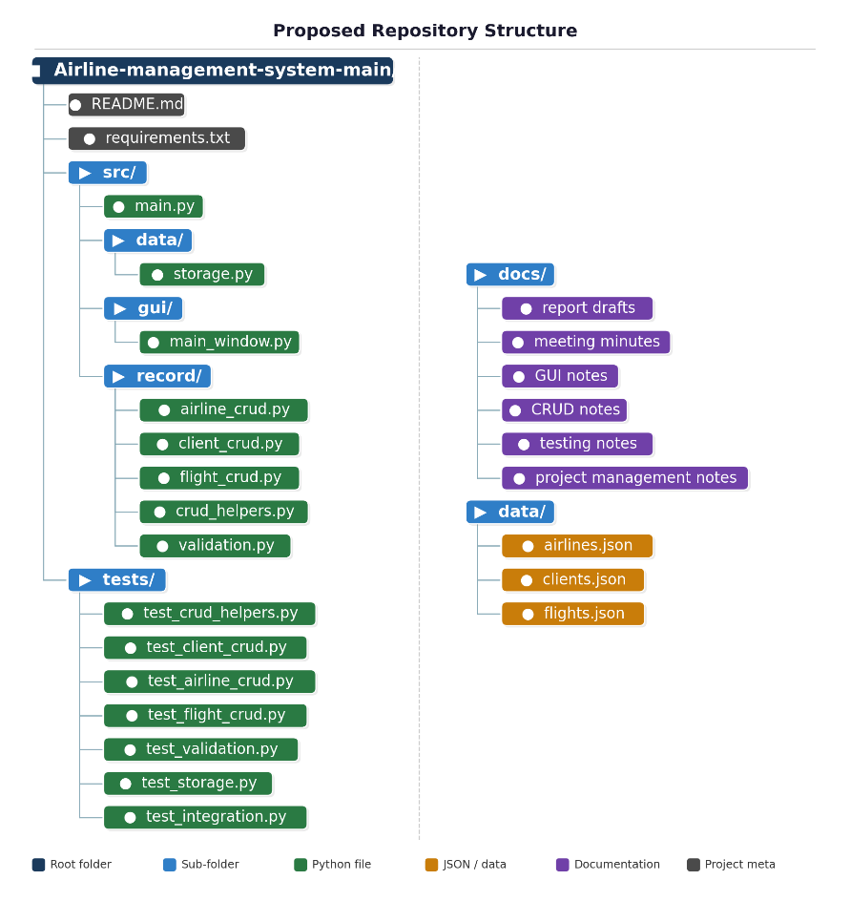
Figure 4. Repository Structure in the GitHub

Team Roles and Contributions

Full Name | Role / Tasks
- Abdel Fattah Hasan | CRUD logic, Storage and integration, and proofreading
- Amber Mary-Anne Harris | Project management and documentation
- Brentin Govender | Validation / flight logic support
- Mohamed Ahmed Deria | Testing
- Eboserieme Anetor | GUI / UX

